<https://www.npmjs.com/package/cat-me>

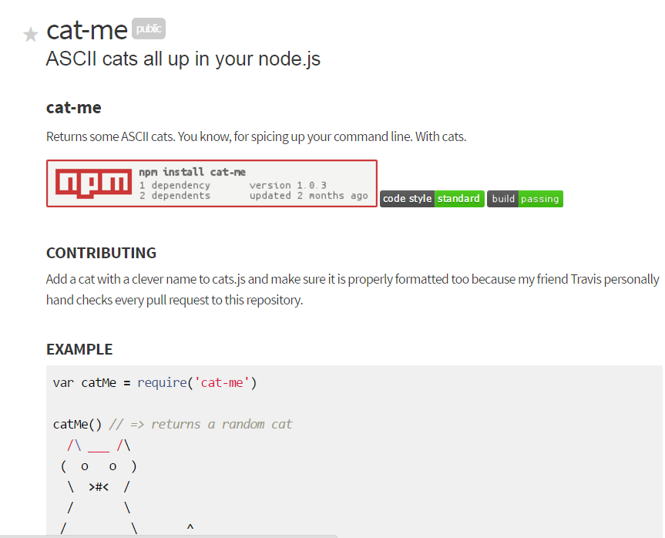

Before npm install cat-me



After the installation:

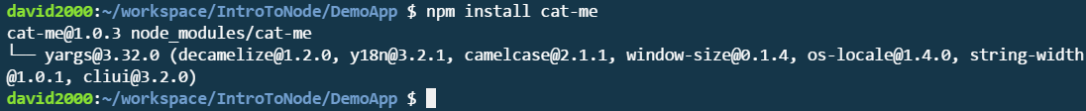

You will notice that the cat-me module(libraries) will be added under the newly created “node-modules” folder.

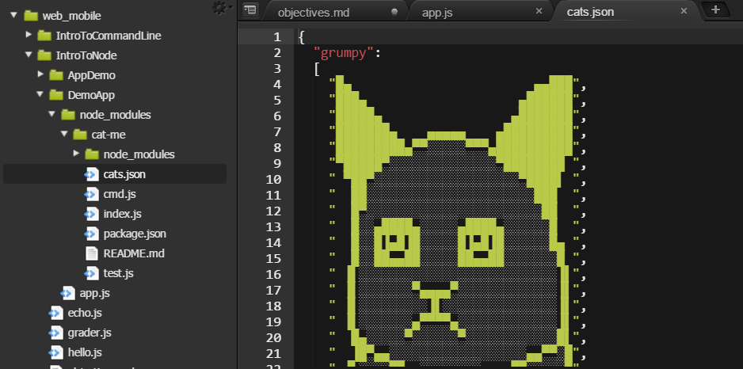

3: use the module: in the app.js:

var catMe **=** require('cat-me')

catMe() *// => returns a random cat*

  /\ ___ /\

 (  o   o  )

  \  **>**#**<**  /

  /       \

 /         \       **^**

|           |     *//*

 \         /    *//*

*///  ///   --*

In the app.js:

var catMe = require("cat-me");

// catMe() will return a ramdom cat. to print it out using console.log()

console.log(catMe()) ;

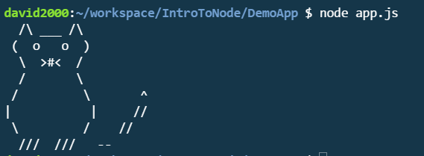

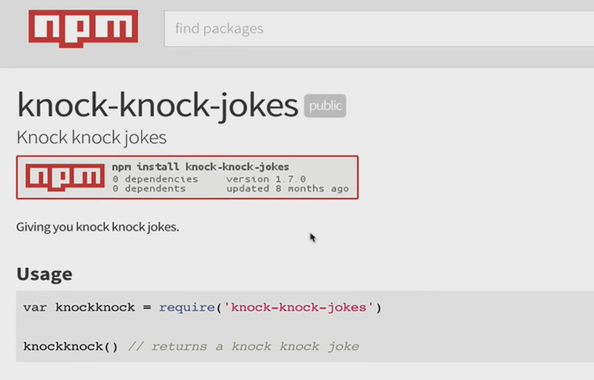

When you install package, make sure in the correct project folder. Otherwise modules will not be added



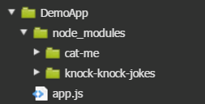

In the require.js:

var joke = require("knock-knock-jokes") ;

console.log(joke()) ;

